CS5041 P3: Board Game

| 180007044  University of St. Andrews  St. Andrews, the United Kingdom  hs99@st-andrews.ac.uk |
| --- |

# introduction

Board game is a type of games which is popular in parties or families. Because these games always need multiple players. For example, Poker is one of the most famous and the most historical board games, which is prevalent around the world.

With the help of some modern technologies, some board games could be more interesting and give better experience of interaction to players. This report will briefly introduce an answer-question game called *Answer Me if you can!* implemented by several kinds of technologies containing Android, Arduino and 3D printing.

# basic design

There are two parts in the finished product: a prototype whose casing is made by 3D printing and handwork, with Arduino modules inside.

## Prototype

### Arduino

In this product, Android app communicate with Arduino through Bluetooth. So, there is a Bluetooth shield (HC06) connected with Arduino. Besides, 2 buttons, 3 LEDs (red, yellow and green), 1 continuous servo are also involved into the system.

### Casing

It is not realistic to let every user interact directly with Arduino modules, hence the casing is necessary to make it more common to touch.

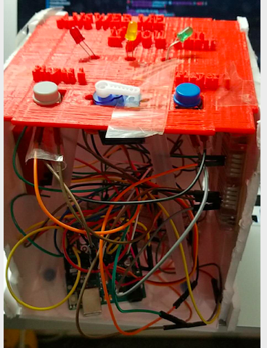

**Figure 1. Inside structure of final prototype**

In design, the whole casing is supposed to be made by 3D printing. However, because of the limitation of time and device, the ceiling is the only part printed, while other parts are made with foamboards by handwork.

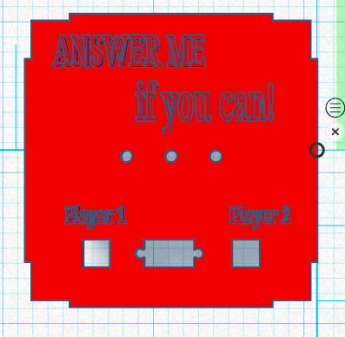 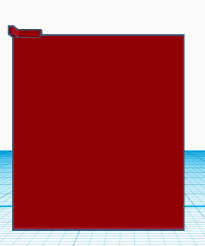 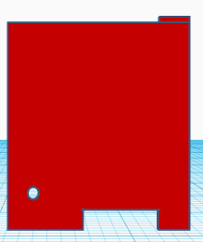 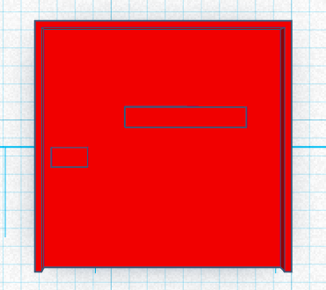

**Figure2. Design of the casing (from left to right: ceiling, left/right/front wall, back wall, floor)**

Six parts are assembled through the physical mechanism. Here are details of each part:

**Ceiling:** The three small holes in the middle part of the ceiling is used to show LEDs, while the two small square holes at corners are set for buttons. The larger square hole is supposed to hold the servo.

**Left/right/front wall:** The little L-shape part on the top of the wall is supposed to catch the ceiling and other walls. Although the final product is more complex, the basic combination method is totally like this.

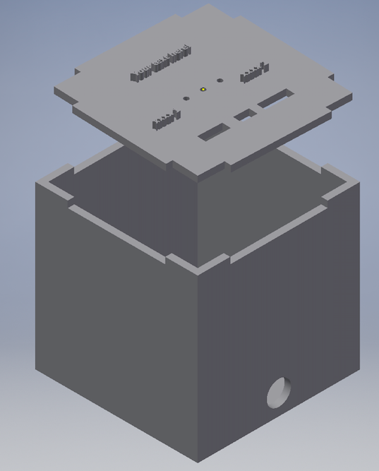

**Figure 3. Combination of the casing**

**Back wall:** There is a small square hole at the bottom, which is used to show two connectors of Arduino to users so that they could power the board. The small circle next to it is used to show the light produced by Arduino Uno and the Bluetooth shield to inform the users if the product is working or not.

**Floor:** The fence around the floor is used to fix the product, while the two small squares at the middle part are used to fix modules (canceled in the final version)**;**

## Process of the game

There are 1 host and 2 players involved in the game

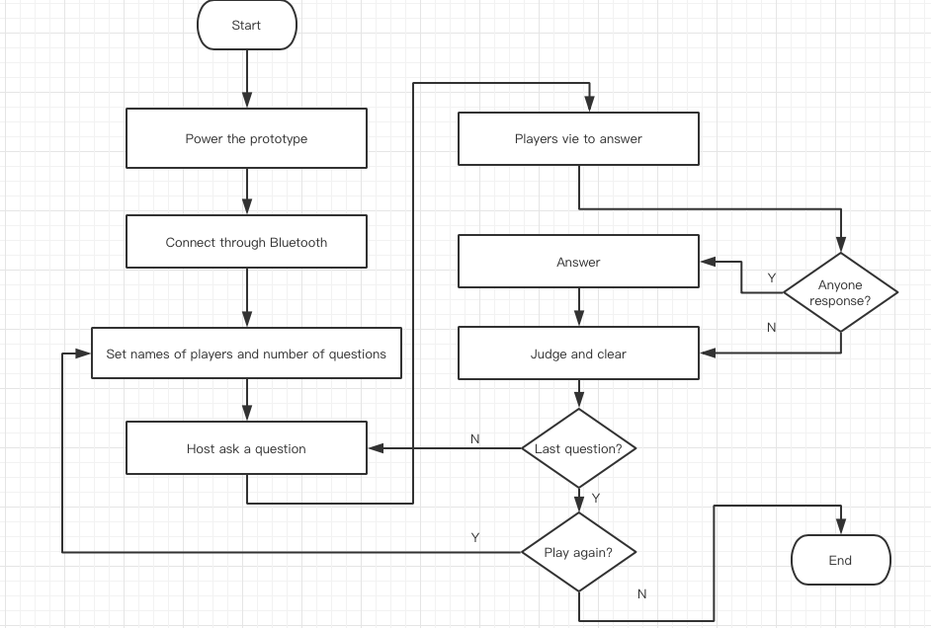

**Figure 4. Process of the game**

More details of each phase would be indicated in the next part.

# details

## Bluetooth

As it is mentioned before, the Android app developed for this game communicates with Arduino through Bluetooth. The app provides thorough functions about Bluetooth.

### Turn on Bluetooth

If the Bluetooth of the Android device has not been turned on, users could complete within the app by just a button.

### Find devices

If the Bluetooth has been turned on, users could find other Bluetooth devices around them by clicking the button again. Paired devices, which are marked obviously, always show before those not paired.

### Pair

To pair with the Arduino prototype, users could click the corresponding name (HC06 in this case) or address and input the default PIN code (1234) in the emerged dialog.

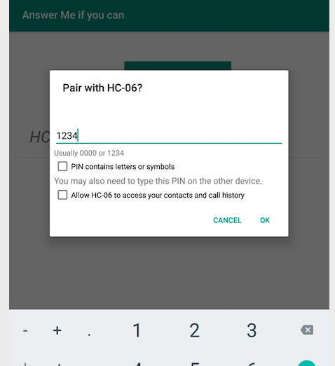

**Figure 5. Bluetooth pair**

### Connect

If users click a paired device, two devices would be tried to connect by socket.

## Game

### Setup

Before the game starts, the host should set the names of players and the number of questions in this round.

### Ask a question

After the count-down and three LEDs go out one by one, the game comes to the first phase of the first question, in which the host should pose a question to players.

### Vie

In this phase, two players could vie for the answer right by press their buttons on the prototype, and the yellow LED would keep flashing and produce a pressing atmosphere.

The player who firstly presses his button would gain the answer right. The result of vying would be shown by both servo which would point at the player getting the right and app.

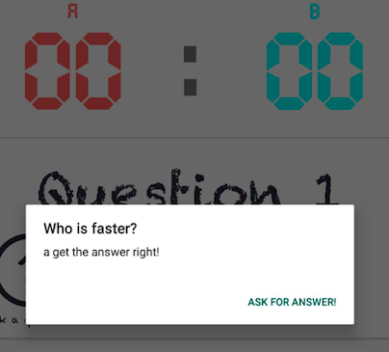

**Figure 6. Result of vying**

If no one press the buttons, the result of this question would be regarded as draw and nobody gets scores.

### Answer

After someone takes the answer right, 30 seconds are given to answer the question and three LEDs would flash together, suggesting 3 results of the question. The host could judge the answer by clicking emojis at two sides of the screen.



**Figure 7. Answer correct (left) and wrong (right)**

If the player could not finish the answer in limited time, the result would be regarded as wrong. The correct answer would bring 1 score to the answerer, while the wrong answer would give 1 score to the opposite.

### Clear

According to the result of the current question, the corresponding LED would rapidly flash for 30 times at the start of this phase and then keep lit.

|  |  |
| --- | --- |
| **Result** | **LED** |
| Correct | Green |
| Wrong | Red |
| Draw | Yellow |

Table 1. Result and corresponding LED

The score would change according to the result, and then the host could press the button at bottom to go to the next question or choose to start another round from setup or exit the game.

## Multi-model design & source

### Animation

Animations of Android app takes a large part of work in this practice, which are shown thoroughly in the video of the delivery.

### Sound

Sounds of this game are played by android device at the time of count-down and judging the answer of players.

### Source

All sources of fonts and sounds are downloaded from the Internet.

# Conclusion

Although there are still some defects in the finished product because of the limitation of time, device and personal ability, technologies including Android, Arduino and 3D design are fully explored.

Although a certain technology could performance well in a certain area, the combination of several technologies is necessary in many situations for interactional design.